ACTIVITY 1 READING & VIEWING
ADVERTISEMENT
1.1 Read the following poster and complete comprehension questions.
a) What trip were the Year Two learners invited to?
The Year Two learners were invited to a special insect - spotting trip.
b) On what day and at what time will the trip start?
The trip will start on Wednesday 26 March at 09:00
c) What must the children bring with them?
The children must bring their own lunch and drink, pen, notebook, sun hat and a camera.
d) Which headings attract your attention?
The two headings that attract my attention are:
Are you coming too? and What’s happening these holidays?
e) What do the pictures tell us?
The pictures tell us that children are taking a hike in nature.
Learner’s own answer that shows insight.
f) What insects are mentioned in the poster?
The following insects are mentioned in the advertisement: bees, butterflies, ants, ladybirds and grasshoppers.

g) Circle the correct word in brackets.
This advertisement will attract the attention of (party lovers / nature lovers) h) If you join the environmental club, you will learn more about
animals and insects
i) Will you join Olympia Park School Environmental Club? Explain your answer. Learner’s own answer that makes sense.

1.2 Read the following advertisement and complete comprehension
questions.
Circle the letter of the correct answer.
a) What product is being advertised?
A cell phone
B back pack
C Lunch pack
b) Who is the advertisement aimed at?
A old people
B teenagers
C school children
c) Which of these is NOT mentioned in the advertisement?
A It has wheels
B It is colourful
C It has hidden pockets
d) What does “get yours before it’s too late” mean?
A They may sell out quickly
B They are very cheap
C Everyone should have one

ACTIVITY 3 LANGUAGE STRUCTURE & CONVENTIONS
COMPOUND WORDS
Single word | Single word | Compound word
rain | bow | rainbow
back | pack | backpack
book | note | notebook
man | fire | fireman
bean | bag | beanbag
pot | flower | flowerpot
dragon | fly | dragonfly
sun | flower | sunflower
cake | pan | pancake
bag | hand | handbag
paint | brush | paintbrush
coat | rain | raincoat
lady | bug | ladybug
foot | ball | football
cow | boy | cowboy
box | mail | mailbox
school | bag | schoolbag
brush | tooth | toothbrush
cup | cake | cupcake
lip | stick | lipstick

ACTIVITY 5 LANGUAGE STRUCTURE & CONVENTIONS
CONTRACTIONS
1. The Tear Thief (is not) isn’t visible.
2. The girl (was not) wasn’t sad any more.
3. You (are not) aren’t funny.
4. They (were not) weren’t crying.
5. (Do not) don’t cry over spilt milk.
6. We (did not) didn’t see the Tear Thief.

ALPHABETICAL ORDER
Write the following compound words in alphabetical order.
rainbow toothbrush backpack schoolbag cowboy cupcake
backpack cowboy cupcake rainbow schoolbag toothbrush

ACTIVITY 6 LISTENING & SPEAKING / READING / WRITING
INSTRUCTIONS
a) Listen to instructions on how to fold a paper airplane.
b) The following vocabulary is important when folding paper. Choose the correct meaning on the board for each word and complete the activity.
HORIZONTAL:
LEFT RIGHT
Parallel to the plane of the horizon. A horizontal line goes across.

VERTICAL:
TOP

BOTTOM
upright, erect,
a vertical line goes up and down.

CENTRE:

place in the middle.

CORNERS:

A place or angle where two sides or edges meet.

TUCK IN:
Push, fold, or turn (the edges or ends of something, especially
a garment or bedclothes) so as to hide or secure them, make a
flat.

EDGES:

the outside limit of an object, area, or surface.
border
c) Instructions for folding a paper airplane
You will need:
1. Paper
2. A pair of scissors
3. A ruler

Now look at the pictures and write instructions for folding a paper
airplane.
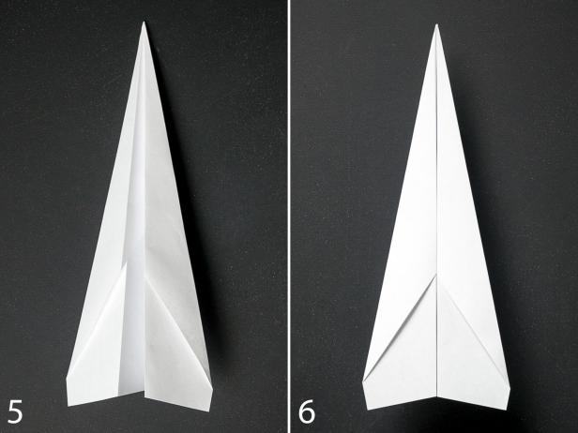
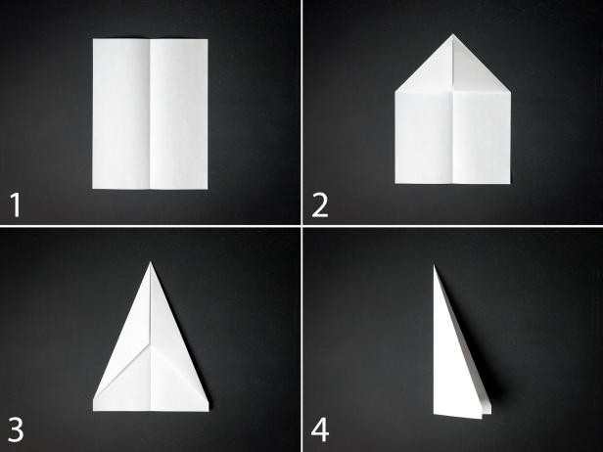

Instructions
- Fold the paper in half vertically.
- Unfold the paper and fold each of the top corners into the center line.
- Fold the top edges into the center line.
- Fold the plane in half toward you.
- Fold the wings down, matching the top edges up with the bottom edge of the body.

ACTIVITY 7 WRITING & PRESENTING
INSTRUCTIONS
Put the instructions in the correct order.
How to make a paper hat

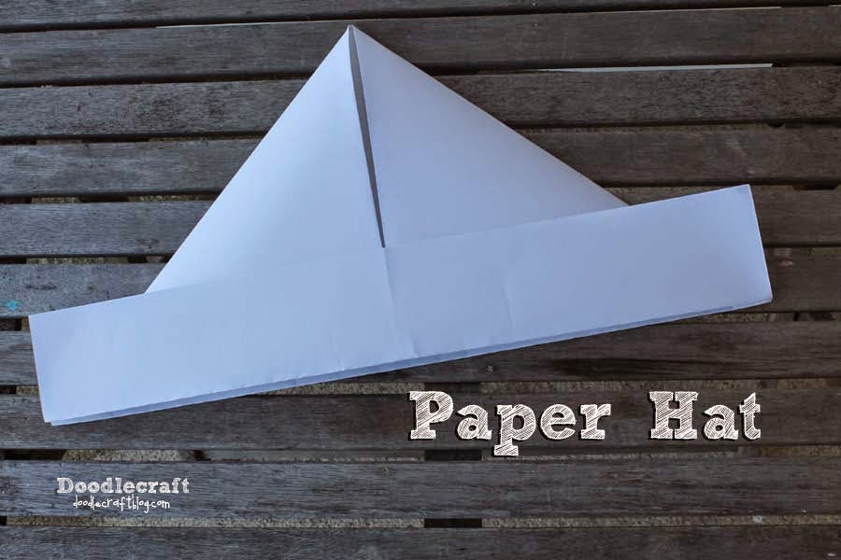

- Use a piece of elastic to hold the hat in place.
- Fold right and left sides towards the middle to form a point.
- Open bottom and fold bottom up on back and front.
- Fold newspaper in half.
- Fold top down to meet bottom.

1. Fold newspaper in half.
2. Fold top down to meet bottom.
3. Fold right and left sides towards the middle to form a point.
4. Open bottom and fold bottom up on back and front.
5. Use a piece of elastic to hold the hat in place.

ACTIVITY 8 LANGUAGE STRUCTURE & CONVENTIONS
Compound words
1. Go to your (class + room) classroom
2. The (fire + man) fireman puts out the fire.
3. My father reads the (news + paper) newspaper
4. I like a sweet (pan + cake) pancake
5. My favourite flower is the (sun + flower) sunflower

Rewrite the sentences and correct the spelling errors.
1. I made notes in my notebook.
2. My backpack was very heavy.
3. She bought a new schoolbag.
4. He had cupcakes in his lunch tin.
5. I wore my raincoat on rainy days.

ACTIVITY 9 LISTENING & SPEAKING
Take part in discussion on pictures of children playing games.

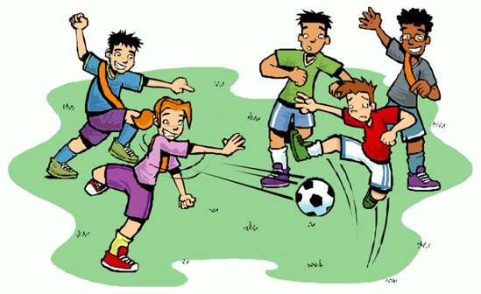
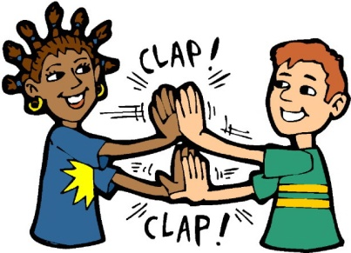
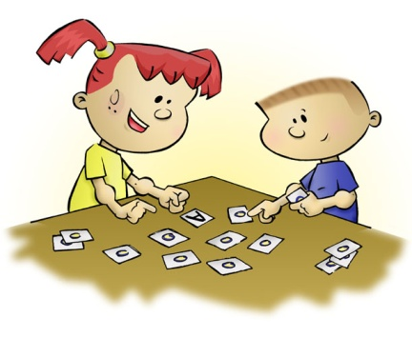
Clap-clap game
Soccer
Language game


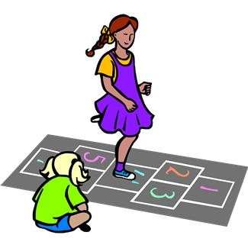
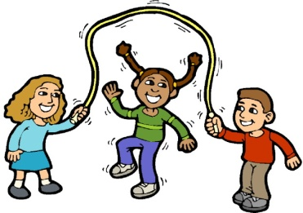
Computer games
Hop scotch
Jump rope

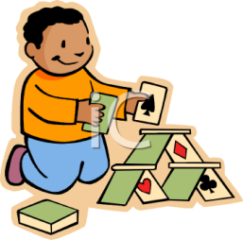
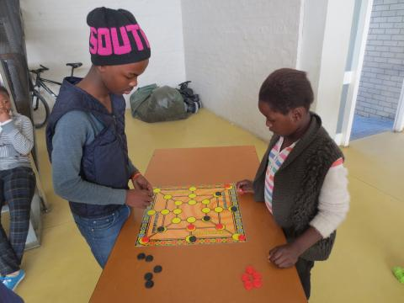

Card stacking
Kite flying
Morabaraba

ACTIVITY 10 READING & VIEWING
Reading a procedural text
Morabaraba an African board game
Morabaraba (or umlabalaba) is a popular board game for two players.
The game was often played by boys herding cattle.
They drew the board on the ground. They played with stones.
You will need:
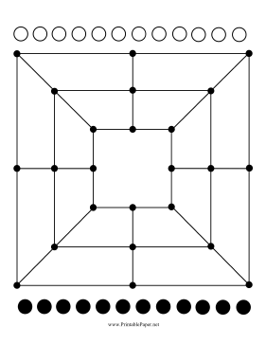
A board
12 small black stones
12 small white stones

Instructions: Fill in the missing words.
1. Each player has 12 stones, called ‘cows’.
2. The player with the white stones begins.
3. Each player takes a turn to put a cow in an empty circle on the board.
4. The aim of the game is to make rows of three cows on the board.
5. When a player makes a row of three cows, the player may then ‘shoot’ or take one of the other player’s cows off the board.
6. When all the cows are on the board, a player can move a cow from one circle to the one next to it.
7. The game ends when one player cannot move any cows or has only two cows left.

Answer comprehension questions
1. Who plays first in this game?
The player with the white stones plays first in this game.
2. What is a cow in this game?
In this game a cow is a stone.
3. Where do the players put the stones?
The players put the stones in an empty circle on the board.

4. What is the aim of the game?
The aim of the game is to make rows of three cows on the board
5. How can you win the game?
- A win occurs if one opponent has just two cows or if there are no moves.
- If either player has only three cows and neither player shoots a cow within ten moves, the game is drawn.
- If one person cheats, then the other one wins by default.

6. Why do you think the stones are called cows in this game?
The stones are called cows because the game was often played by boys herding cattle.

ACTIVITY 11 READING & VIEWING
READING COMPREHENSION
a) Where did Nelson Mandela grew up?
Nelson Mandela grew up in Qunu in the Eastern Cape.
b) Complete the sentence:
Nelson Mandela is known for his love for children.
He places great emphasis on the importance of family
Nelson Mandela is called the father of the nation.
c) During his term as president, Nelson Mandela did something to show his support of the poor people of South Africa. What was that?
During his term as president, Mandela gave half his salary to the poor, specifically to children.

d) How will History judge us according to Nelson Mandela?
History will judge us by the difference we make in the everyday lives of children.
e) What is the most powerful weapon you can use to change the world?
Education is the most powerful weapon you can use to change the world.
f) What would you do to uplift our country if you were the president?
Learner’s own answer that makes sense.

ACTIVITY 12 LANGUAGE STRUCTURE & CONVENTIONS
Combine sentences using conjunctions.
a) Mandela is called the father of the nation because he loved and supported the children.
b) He is respected and he is loved around the world.
c) Children are the most important asset in a country and so they must be looked after.
d) Mandela gave half his salary to the poor until the day he retired.
e) Nelson Mandela was a strict man but he was a fair man.

